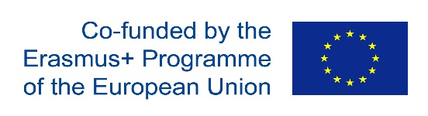 | 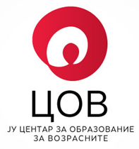

We, Adult Education Center,Adress: DimitrieChupovski 13, 1000 Skopje, Republic of North Macedonia, are seeking for EU Consultant/Expert with significant experience inpromotional activities in adult education/validation of non-formal and informal learning (VNFIL)

Apply by: 04.08.2019
Start date: 01.09.2019
Duration:20 WD

NATIONAL COORDINATOR FOR ADULT LEARNING WORK PLAN: MACEDONIA
AGREEMENT NO. 2017-2289/001-001
PROJECT NO. 592010-EPP-1-2017-1-MK—EPPKA3-AL-AGENDA
FINANCED UNDER ERASMUS +: SCHOOLS, VOCATIONAL TRAINING, ADULT EDUCATION PLATFORMS

TERMS OF REFERENCE

- Background

Adult Education Center is implementing the project: National Coordinator for Adult Learning Work Plan: Macedonia, funded by Erasmus + Programme.
The main objective of the project is to support establishment of the national Validation of non-formal and informal learning (VNFIL) system, especially in the phases of Identification and Documentation (VNFIL processes and procedures typically involve four stages: 1) IDENTIFICATION of the individual’s competences (i.e. learning outcomes) acquired through non-formal and informal learning; 2) DOCUMENTATION of the individual’s learning outcomes from non-formal and informal learning together with supporting evidence; 3) ASSESSMENT of the individual’s learning outcomes through an evaluation of the evidence presented; 4) CERTIFICATION confirming the individual’s achievement of the learning outcomes in question.)
In order to reach the above set objective, the following activities shall be implemented:
- Development of standards, portfolio for VNFIL candidates, program and learning materials for VNFIL Councillors
- Documents shall be developed that include standards for trainers of VNFIL Councillors; Portfolio for VNFIL candidates; Training program for VNFIL Councillors; Learning materials for trainers of VNFIL Councillors. Study visits shall be conducted in order to learn form best practice while developing the documents and strengthen the capacities of AEC in the area.
- Awareness rising training shall be organized for 20 representatives from main stakeholders, in order to introduce them to the main principles of VNFIL and strengthen the institutional cooperation on the specific topic.
- Existing AEC MIS software shall be updated to design and administer a database of VINFL Councillors and the relevant procedures.
- Regular meetings of the Coordinative Body to ensure efficient and effective implementation of the project activities.

The direct beneficiary of this project is the Adult Education Center.
Indirect beneficiaries are all relevant stakeholders and the wider community.
Primary target group are potential national providers of VNFIL and the national institutional network for adult education.
Secondary target group are all adults that have a need to validate their prior learning, companies/employers, the policy makers and the wider community.

- Scope of services

In close cooperation with the national project team the consultant shall be responsible for:

Deliverables | Deadline | No. of WD
- Developed Strategic plan for public awareness campaign about VNFIL opportunities and benefits | 20thNovember 2019 | 20WD
- Required qualifications and experience

Essential:
- Master’s Degree or equivalent in an education and training related subject
- At least 15 years professional experience in the adult education sector
- Experience in at least 2 projects in the area of VNFIL
- Experience in promotional activities and development of strategies in the area of adult education and VNFIL/LLL
- Excellent fluency in English language

Desirable:
- Knowledge of EU adult education policy, specially EU VNFIL policy
- Experience in adult education/VNFIL promotional activities
- Experience in conducting EU projects and implementation, (at least 20 projects)
- Experience with stakeholders in the Republic of North Macedonia in the field of adult education and LLL

- Facilities

The task will be home based with one mandatory meeting in Skopje.
All Facilities needed for the Skopje meetings will be provided by the Adult Education Center.
All travel arrangements to Skopje and accommodation will be provided by the EU Consultant/Expert.

- Application

To apply for this position please send your CV in the EU expert format as well as short draft methodology with timetable and cost-estimate of services.
Please be aware that CVs will be evaluated against the criteria listed above, and that we will only contact those candidates whose profiles correspond most closely with the required qualifications and experience. Incomplete applications will not be considered.
Applications should be submitted tokonstantin.hristovski@cov.gov.mknot later than04.08.2019.

